Table of contents
1. Table of contents 1
2. Inventory of temporary elements 1
3. Inventory of permanent elements and farms 2
4. Records during post-breeding Houbara counts 4
a. Permanent elements 4
b. Temporary elements 4
5. Non standardized inventory 4

Inventory of temporary elements

A dedicated protocol has been set in 2012. It is constituted by several transect joining the existing standardized observation points (figure 1). All transects are performed at the same time, and observers record all temporary anthropogenic features they detect from the transects and observation points. This survey is generally done 6 times per year.
One drawback is the “pseudo-standardized” nature of this protocol, as path between points, although theoretically defined, varies among sessions.

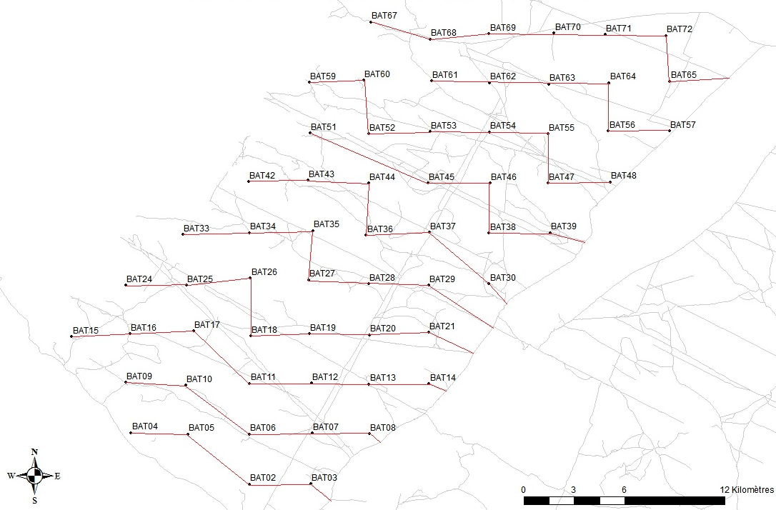
Figure 1. Transects and observations points used for the anthropogenic impact survey

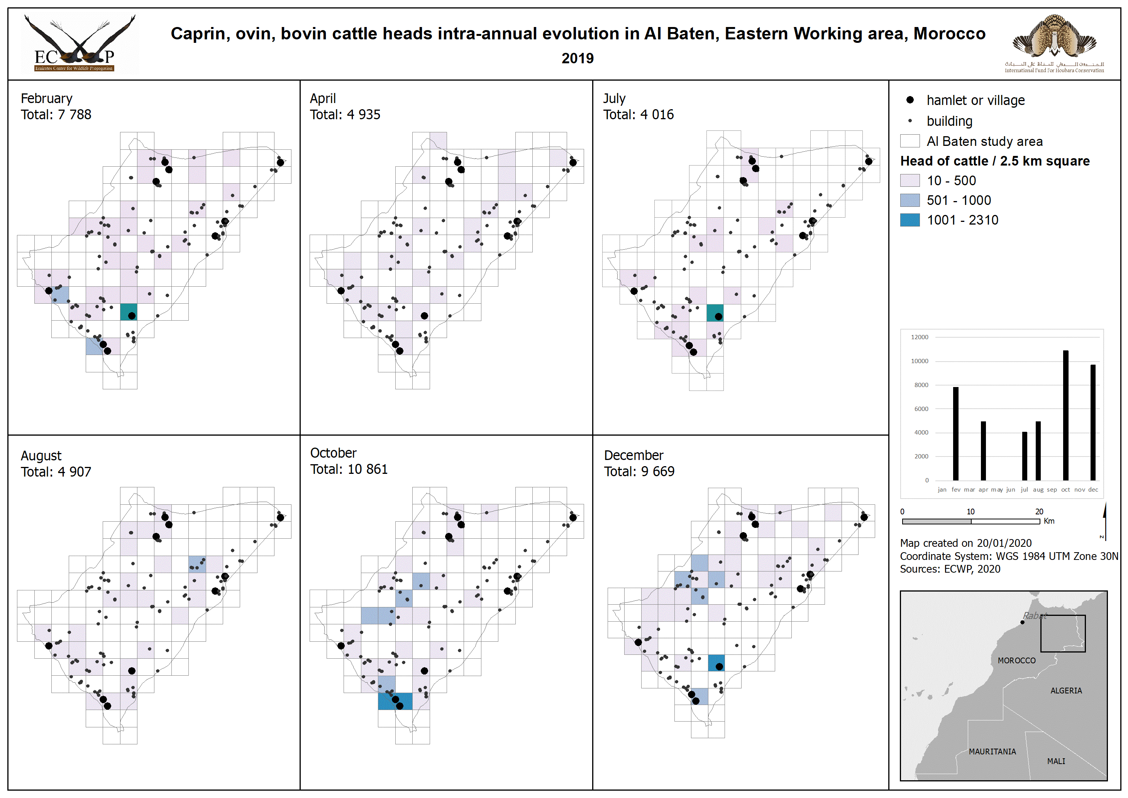
Figure 2. Illustration of results of anthropogenic impact assessment protocol results in 2019

Inventory of permanent elements and farms

Once a year, all permanent elements (buildings, wells etc.) and tree farms contours are inventoried. Permanent elements are entered in ecology database while farms are stored in GIS database.
Farm inventory started in 2017 while permanent elements inventory started in 2011.

GIS and ecology teams are now working closely to perform farms inventory comparing remote sensing results to ground surveys.
Some data still need to be recorded in the field due to their lack of vegetation:
- Part of the farms not yet under cultivation but already inaccessible (fenced areas).
- Plowed fields in permanent farms.

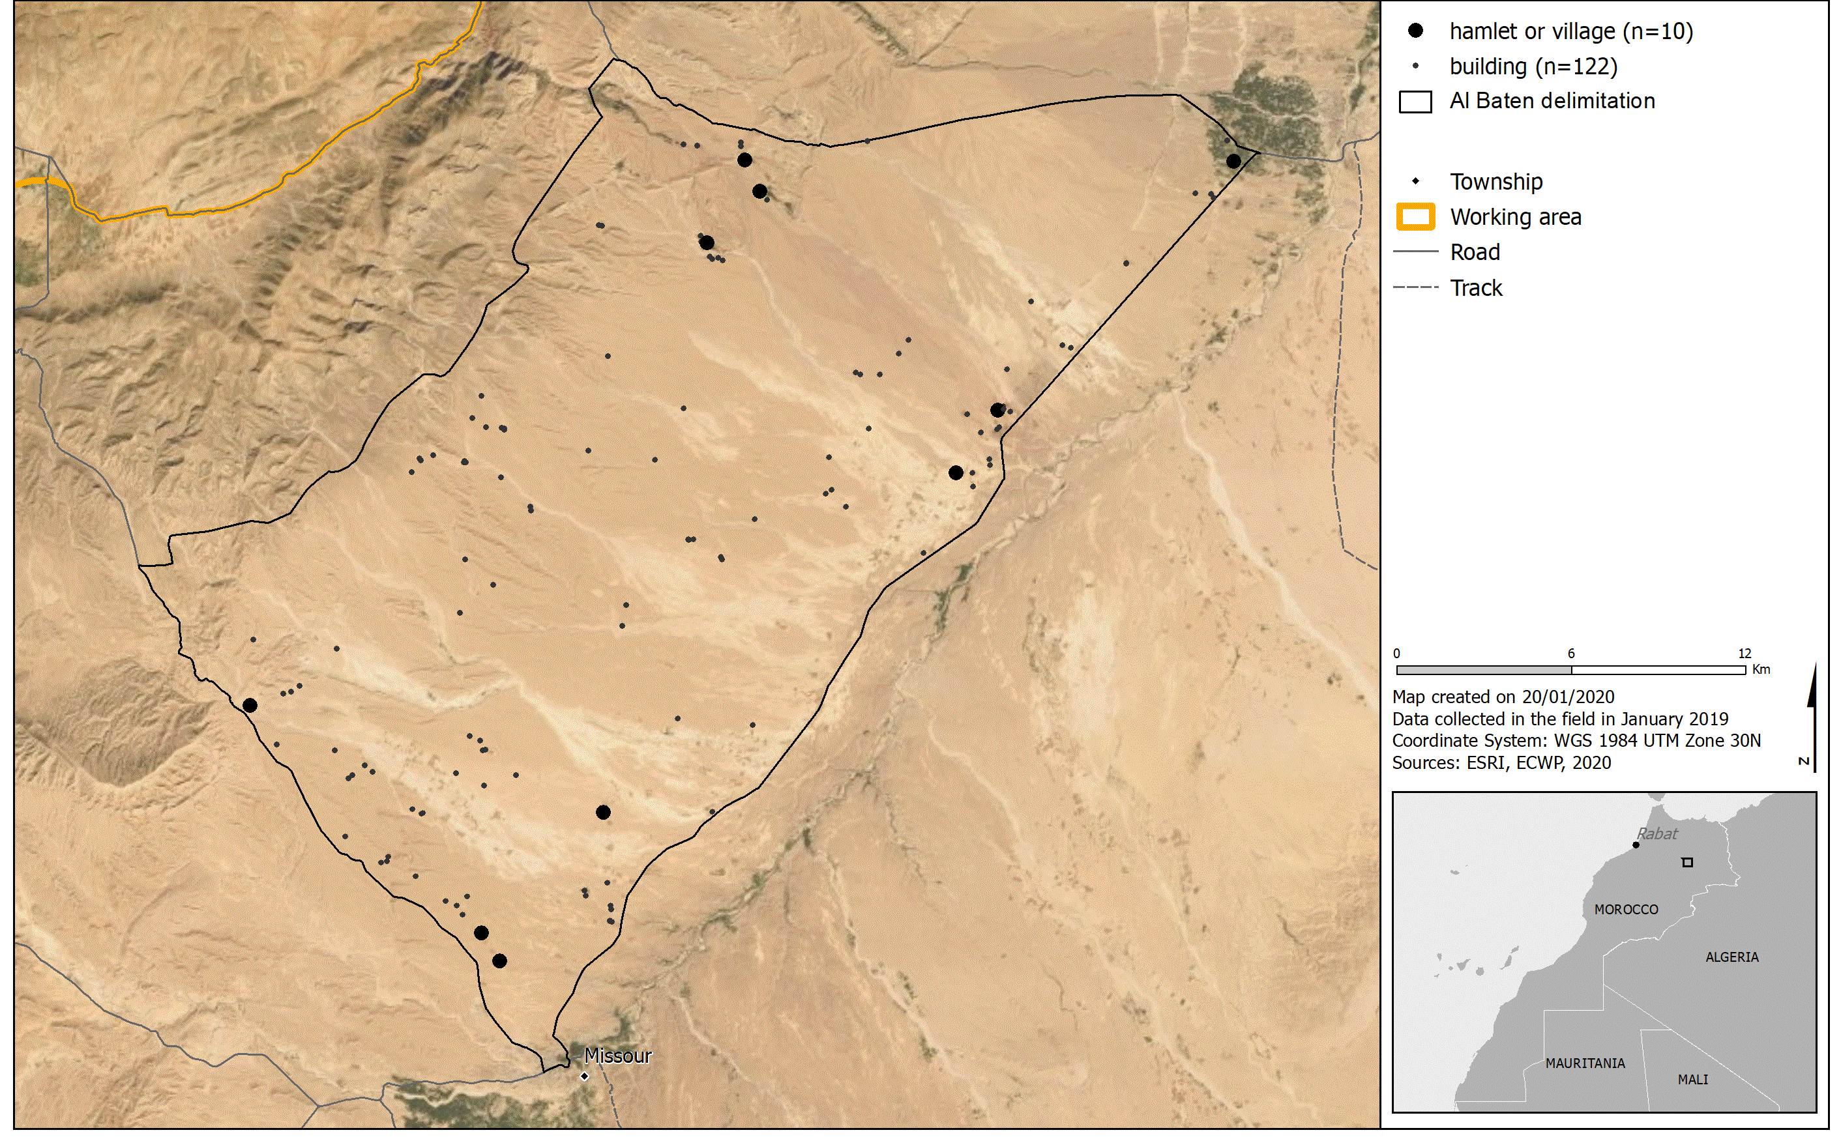
Figure 3. Permanent anthropogenic elements inventoried in 2019

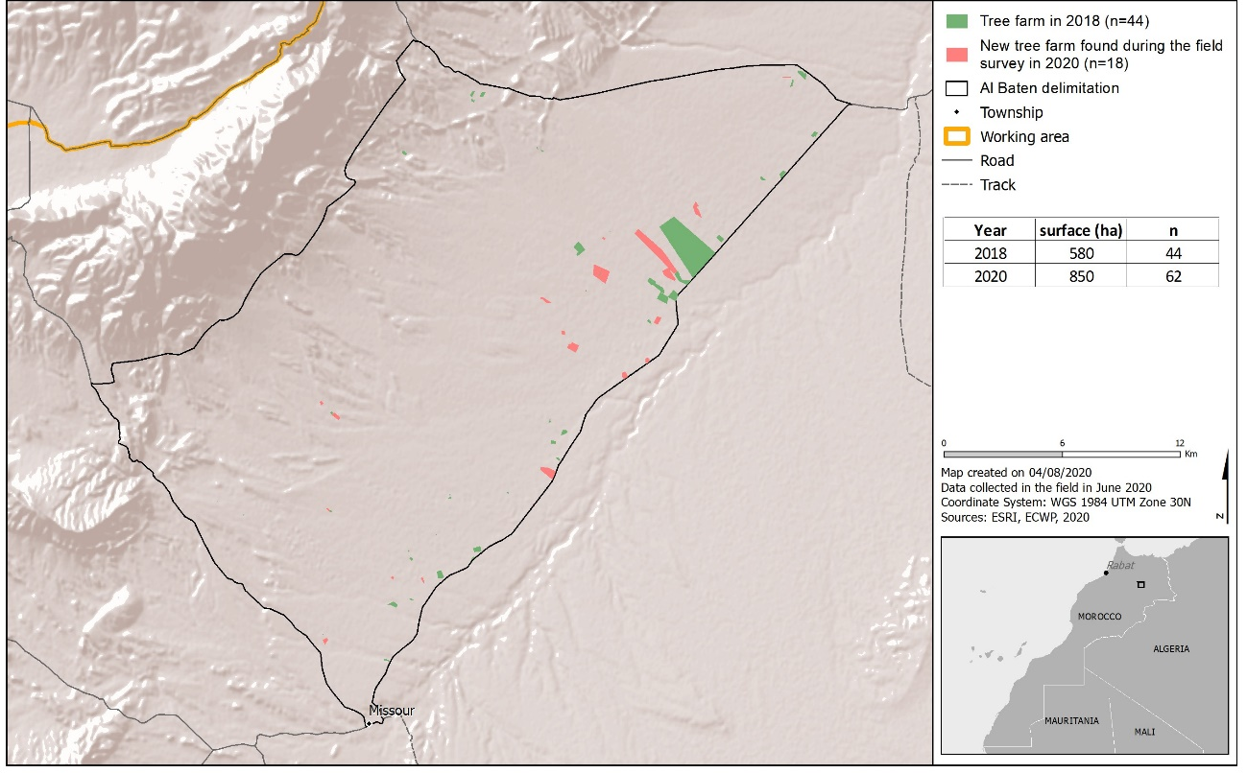
Figure 4. Evolution of farms between 2018 and 2020

Records during post-breeding Houbara counts

Anthropogenic elements are recorded systematically from standardized circular observation points performed during post-breeding counts, since 2001.

Permanent elements

The recording of permanent elements is realized at the first visit of the observation points of the primary grid of each area.
The secondary grid being interposed between the points of the primary grid, the area is supposed to be covered by the observations from the primary grid.
Estimated locations of all permanent elements in a radius of 1.5km around the observation points are noted, whether by projected GPS points (until 2018) or by recording estimated distance and bearing (since 2019).

Temporary elements

Temporary elements are recorded for each visit independently of the grid.

They are recorded the same way as permanent elements. Estimated locations of temporary elements in a radius of 1.5km around the observation points are noted, whether by projected GPS points (until 2018) or by recording estimated distance and bearing (since 2019).

Non standardized inventory

Until 2011, all elements, temporary or permanent, within 400m from the car were systematically recorded while driving and during any type of field activity.
This protocol was not adequate since it was applied where most activities were taking place and did not necessarily cover the area. Additionally, there was a redundance for permanent elements. In parallel, a certain tiredness of the fieldworkers was noticed, given that they were spending more time recording anthropogenic elements than really working on Houbara. All these elements lead to the implementation of the dedicated survey in 2012.

